European Parliament Initiative Report on
"New opportunities for small transport businesses,
including collaborative business models"
CONSULTATION

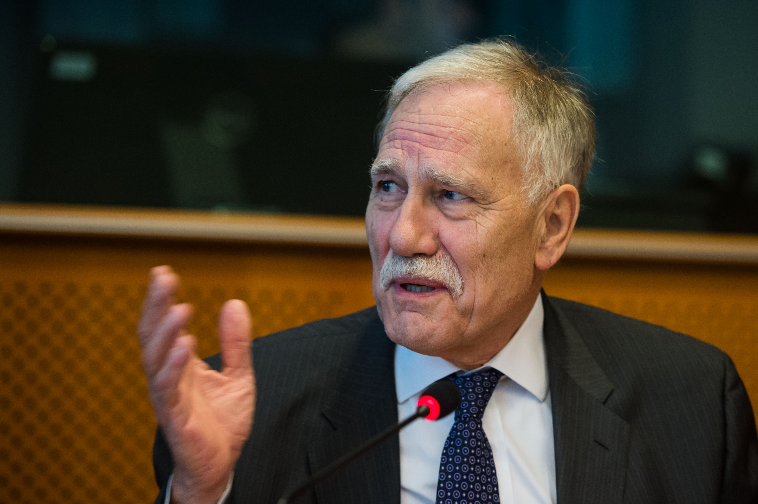
"In November last year, the Transport and Tourism Committee of the European Parliament has decided to elaborate an initiative report on new opportunities for small transport businesses, including collaborative business models. Being rapporteur on this dossier, I would like to invite all stakeholders concerned by this topic to submit their suggestions on how to allow small transport businesses to cope with and benefit from the recent evolutions in the transport sector."
Dominique Riquet (ALDE-UDI)
Member of the European Parliament
Vice-Chair of the Transport and Tourism committee
Member of the Industry, Research and Energy Committee
Chair of the Long-Term Investment and Reindustrialisation Intergroup

INFORMATION
This initiative report aims at determining what the current challenges for European small transport businesses are. On this basis, we will propose some ways to move forward in order to reinforce their competitiveness while ensuring a sustainable and coherent development of the transport system as a whole and a level playing field among the various actors. Designed to inspire the way legislators will tackle these issues, the report will restrict itself to SMEs and start-ups relating to mobility as a service (whether they concern people or goods). Industry and infrastructures are therefore not directly concerned by this consultation.

The final report should be adopted in September this year and a first draft will be made for the beginning of April for examination by the committee later in that month. The deadline for sending your contributions is therefore set on 29 February (as there is one this year). Contributions as well as information requests should be addressed to: dominique.riquet@europarl.europa.eu.

Your contributions will help elaborate the report but their content will not be disclosed publicly. However, in order to ensure transparency, the names of the participants will appear at the end of the draft report.

To help you structure your answers, you will find some indicative questions below. If there is something you would like to share with us and which is not properly addressed by these questions, please do not hesitate to add it to your contribution.

Brussels, 29 January 2016
QUESTIONS
- What are the main challenges for your company today?
- To which extent have you digitalised your processes? How much does your core activity lay on or depend from ICT? Which role does "big data" play for your activity?
- How do you take into account the objective of sustainable development? the recent demographic evolutions (ageing and increasingly urbanised population among others)
- Are you trying to internationalise your services and what are the problems you are facing when doing so? Are so-called "emerging" countries a growth opportunity for your company?
- In which transport mode are you mainly operating? How rigid do you find it to access and to survive in?
- Do you have the impression that entrepreneurs are well-perceived/treated in Europe?
- How do you finance yourself? (grants, loans, external participations...) Are you aware of the different European programmes aimed at supporting SMEs and startups? Do you use them and why?
- If you are a startup, did you feel supported enough during your various steps of development?
- If you belong to the collaborative economy :
  - How did public authorities react to your arrival on the market? What are your relations with the companies belonging to the "old economy"?
  - Taxation, security and social rights are among the main areas of concern: what is your argument and what would be your recommendations?
- Would you say the legal environment you are evolving in is satisfying? (stable over time, harmonised between (EU) countries), clear, adapted to the reality on the ground, covering all situations)
- Do the problems you mention call for better regulation/new regulation? for a better application of the current legislation? For less regulation? At which level? (local/national/European)
- What is your vision of mobility in 5, 10, 20 years? Are you optimist about the future of your company?

ABOUT YOU
- Name and legal status of your company :
- Main country of establishment and countries where you provide your services :
- Number of employees/service providers on which you base yourself to realise the company's mission :
- Type of service provided :
- Development stage :
- Turnover and valuation estimate :
- Contact (email + tel.) and website/page on social networks/App :

